CHARLOTTE PROJECTS

Week 2 - Class 3 Guided Student Lab
MEASURING VARIABILITY IN CLEANED PRODUCTION DATA
Range | Variance | Standard Deviation | Quartiles | IQR | Potential Outliers
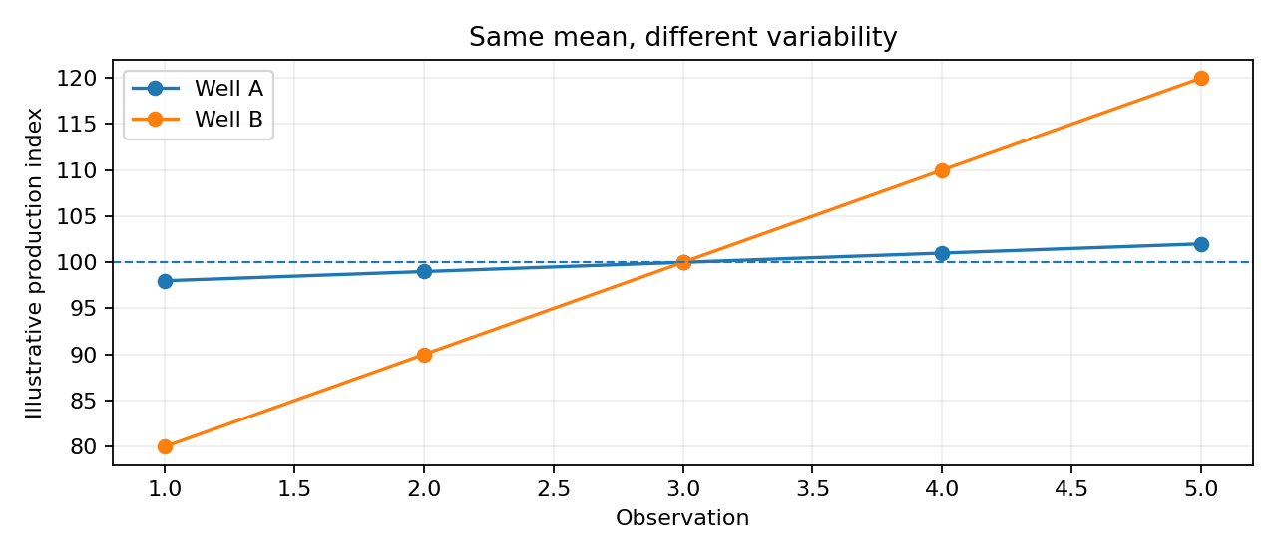

Main question for today: How much does production vary, and which observations deserve closer investigation?
Lab input | What you will use
Workbook | Your Class 2 workbook or the Class 3 continuation copy
Main source sheet | Cleaned_Data - not Raw_Data
Primary measure | Oil_Production_bbl
Context fields | Date, Well_ID, Downtime_Hours, Sensor_Status and Comment
New outputs | Dispersion_Analysis, IQR_Analysis and written interpretation
Important: Do not clean the dataset again just because a statistical result looks unusual. Class 3 uses the cleaned Class 2 data to measure behaviour. Statistical flags are investigated before any further data decision.

1. What you should be able to do by the end
☐ Explain the difference between centre and spread.
☐ Calculate and interpret minimum, maximum and range.
☐ Calculate sample variance and explain its intuition.
☐ Calculate sample standard deviation and interpret it in barrels.
☐ Calculate Q1, Q2/median and Q3.
☐ Calculate IQR and the lower/upper IQR boundaries.
☐ Identify potential outliers without automatically deleting them.
☐ Use operational context to explain what should be investigated next.
☐ Write a short, evidence-based interpretation of production variability.

2. The analysis workflow
Step | Question you are answering
1. Confirm readiness | Is the Class 2 Cleaned_Data ready for analysis?
2. Recall centre | Where is production centred?
3. Measure full spread | How far apart are the minimum and maximum?
4. Measure spread around mean | How widely do observations move around the mean?
5. Measure the middle 50% | How spread out is the central half of the data?
6. Flag unusual observations | Which values fall beyond the IQR boundaries?
7. Investigate context | What do Date, Well_ID, downtime/status/comments tell us?
8. Interpret | What can we responsibly conclude?
Rule for the whole lab: Calculate -> compare -> investigate -> explain. Do not stop at the formula result.

3. Before you start - Class 2 readiness check
☐ Open the workbook you completed in Class 2.
☐ Confirm Raw_Data is still preserved.
☐ Open Cleaning_Log and review the decisions you already documented.
☐ Open Cleaned_Data and confirm your cleaned rows are present.
☐ Confirm Oil_Production_bbl is numeric and is in column D in the standard workbook.
☐ Confirm that true operational zeros were not replaced with blanks, and missing values were not automatically changed to zero.
Instructor checkpoint: Do not proceed until the cleaned dataset is suitable for analysis.

PART A - Reconnect centre with spread
Before measuring variability, remind yourself where the data is centred. You calculated central tendency in Class 2. Today you will place those measures beside measures of spread.

Task A1 - Recall the centre
Measure | Excel formula example | Your result | What the result means
Mean | =AVERAGE(Cleaned_Data!D2:D200) | 1219.06 | The number is the average value of the data
Median | =MEDIAN(Cleaned_Data!D2:D200) | 1240 | The value is the middle value of the dataIt is close to mean
Guided questions:
- Is the mean close to the median, or is there a noticeable difference?
Mean is close to median 1219 and 1240 difference is only 20.94 that is small compared to 1200
________________________________________________________________________________
- If they differ, what kind of values might be pulling the mean away from the median?
____It does not differ_______none_____________________________________________________________________
Think like an analyst: The mean and median tell you about centre. They do not tell you whether daily production is tightly clustered or widely dispersed.

Task A2 - Minimum, maximum and range
Measure | Formula | Your result
Minimum 0 | =MIN(Cleaned_Data!D2:D200) | 0
Maximum 1405 | =MAX(Cleaned_Data!D2:D200) | 1405
Range 1405-0=1405 | =MAX(Cleaned_Data!D2:D200)-MIN(Cleaned_Data!D2:D200) | 1405
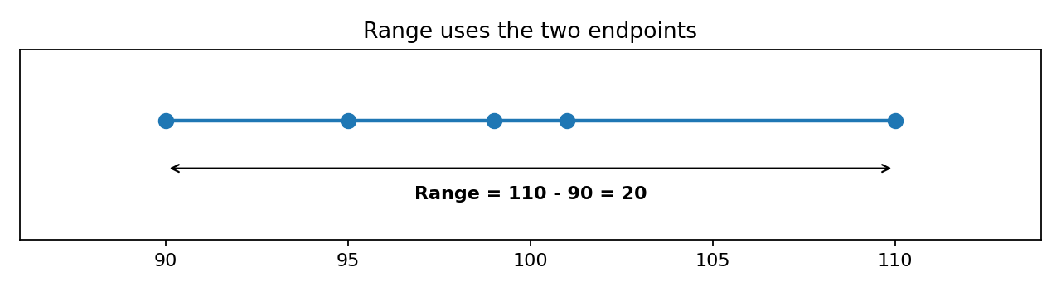
Now answer:
- What are your minimum and maximum oil-production values?
___________MIN = 0 MAX = 1405_______________________________________________________________
- What is the range?
__________1405______________________________________________________________________
- In plain language, what does that range tell you about the full spread of oil production?
___The range shows that oil production values spread from 0 to 1,405, meaning there is a large difference between the lowest and highest production values. _____________________________________________________________________________
- Why could one unusually high or low value make the range misleading?
____An unusually high or low value can make the range misleading because the range uses only the minimum and maximum values. ____________________________________________________________________________

PART B - Variance and standard deviation
Range looks only at the two endpoints. Variance and standard deviation use all observations to describe how values behave around the mean.

Task B1 - Build the intuition for variance
Idea | Meaning
1. Find the mean | This is the centre of the observations.
2. Compare every value with the mean | Each observation has a distance/deviation from the mean.
3. Square the deviations | This prevents positive and negative deviations cancelling each other.
4. Summarize the squared deviations | That summary is variance.
Use Excel: =VAR.S(Cleaned_Data!D2:D200)
Measure | Your result | Interpretation note
Sample variance | 22164367.29 | Large value = more squared spread; small value = less squared spread
- Why do we not simply add all positive and negative deviations from the mean?
Because the positive and negative deviations would cancel each other out, giving a misleading result. Squaring the deviations prevents this ________________________________________________________________________________
- Why is variance harder to explain directly in operational terms?
Because variance is measured in squared units, which are harder to understand in real-world terms. Standard deviation is easier because it uses the original units of production. ________________________________________________________________________________

Task B2 - Calculate standard deviation
Use Excel: =STDEV.S(Cleaned_Data!D2:D200)
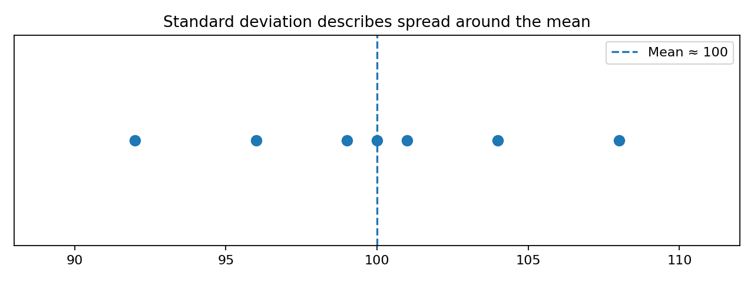
Measure | Your result | Unit
Standard deviation 196.03 |  | barrels of oil production
- What does your standard deviation tell you about how widely production values sit around the mean?
It tells us how much the oil production values typically vary or spread around the mean. A larger standard deviation means the values are more spread out. ________________________________________________________________________________
- Why is standard deviation easier to communicate than variance?
Standard deviation is easier to understand because it is measured in the same units as oil production (barrels), while variance is in squared units. ________________________________________________________________________________
- If another well had the same mean but a much larger standard deviation, what would that tell you?
it mean that the other well's production values have greater variability and are more spread out around the mean. _______________________________________________________________________________
Do not write: "The standard deviation is high, therefore the data is bad."
Better: "The larger standard deviation shows greater variability around the mean. We need operational context before deciding whether that variability is expected or problematic."

PART C - Quartiles and the middle 50%
Quartiles work with ordered data. They help you see where the lower quarter, middle and upper quarter of the observations fall.
Measure | Excel formula | Meaning | Your result
Q1 | =QUARTILE.INC(Cleaned_Data!D2:D200,1) | 25% of values are at or below this value | 1173
Q2 / Median | =QUARTILE.INC(Cleaned_Data!D2:D200,2) | Middle of the ordered data | 1240
Q3 | =QUARTILE.INC(Cleaned_Data!D2:D200,3) | 75% of values are at or below this value | 1287.25
IQR | =Q3-Q1 | Width of the middle 50% | 114.25
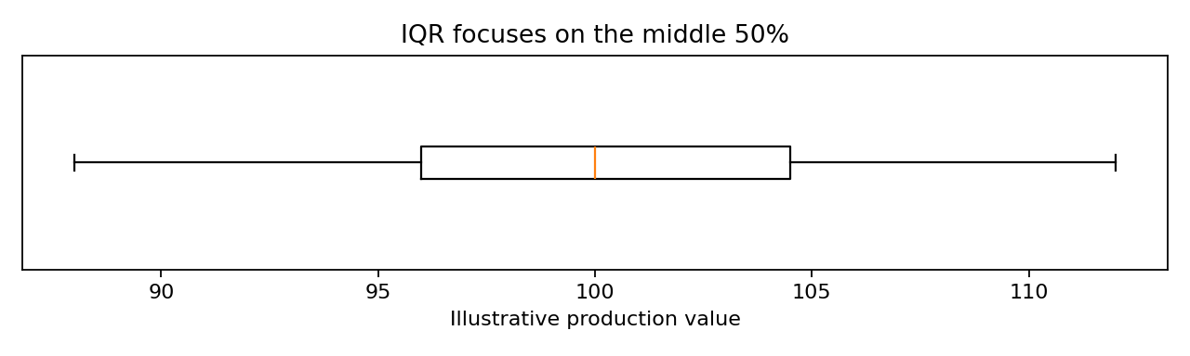

Task C1 - Interpret the middle 50%
- Write your Q1, Q2 and Q3 values in ascending order. 1173,1240,1287.25
Q1 1173
Q2 1240_
Q3 1287.25_____________________________________________________________________________
- What is your IQR? 114.25 Barrels
114.25_______________________________________________________________________________
- In plain language, what does the IQR tell you about the middle 50% of oil-production values?
The 50% of oil value is spread across 114.25 barrels to from 1173 to 1287.25 ______________________________________________________________________
- Why is IQR generally less affected by a very large spike than the full range?
Because the IQR focuses on the middle 50% of the data does not depend on the highest or lowest values. ________________________________________________________________________________
Sentence frame: "The middle 50% of oil-production observations spans approximately 114.25 barrels, from Q1 = 1173 to Q3 =1287.25

PART D - Build IQR boundaries and flag observations
The 1.5 x IQR rule gives us boundaries for potential outliers. It is a statistical screening rule, not an automatic data-cleaning command.
Boundary | Formula | Your result
Lower IQR boundary | =Q1-(1.5*IQR) | 1001.625
Upper IQR boundary | =Q3+(1.5*IQR) | 172.875
Decision rule: If Oil_Production_bbl < Lower Boundary OR Oil_Production_bbl > Upper Boundary, FLAG the observation for investigation.

Task D1 - Identify potential outliers
Filter or scan Cleaned_Data. For every flagged oil-production value, copy the operational context into the table below.
Date | Well_ID | Oil (bbl) | Downtime hrs | Sensor status | Comment/context | Why investigate?
2026-09-03 | WELL-02 | 4850 | 0 | Normal | High oil reading | The value is above the upper IQR boundary and should be checked to confirm whether it is a genuine production value or a data issue
2026-09-07 | WELL-03 | 0 | 6 | Normal | Maintenance shut in | The value is below the lower IQR boundary, but the downtime and maintenance comment provide an operational reason for the zero production.

Task D2 - Investigate before deciding
For each flagged record, ask the following questions. You are not expected to know the final cause; your job is to identify the next useful investigation.
☐ Was the well shut in or partially down?
☐ Did production restart after downtime?
☐ Does the Comment field describe an operational event?
☐ Is Sensor_Status normal or does it indicate a telemetry issue?
☐ Could the unit or data-entry format be wrong?
☐ Does the same well show a similar pattern on nearby dates?
☐ Would another source (historian, meter record, operator log) help confirm the value?
Key principle: Potential outlier -> investigate -> document -> decide. Never "outside IQR -> delete".

PART E - Compare production behaviour between wells
A useful analyst does not only produce one overall statistic. Compare at least two wells. Your instructor may assign the wells, or choose two wells with enough observations.
Simple method: Filter Cleaned_Data by one Well_ID at a time, calculate the measures, and record them below. If your Excel version supports FILTER(), your instructor may demonstrate a dynamic method.
Measure | Well A: ______ | Well B: ______ | Which well shows more variability?
Mean | 1,565.10 | 1,237.10 | WELL-02
Median | 1,202 | 1,370
Range | 3,672 | 1,389 | WELL-02
Standard deviation | 1,154.27 | 434.77 | WELL-02
Q1 | 1,194.25 | 1,366
Q3 | 1,213.25 | 1,380.50
IQR | 19 | 14.50 | WELL-02
- Which well has the higher mean production?
WELL-02 has the higher mean production, with 1565.10 bbl, compared with 1,237.10 bbl for WELL-03. ________________________________________________________________________________
- Which well has the larger range?
WELL-02 has larger range (3672bbl compared with 1389 bbl). ________________________________________________________________________________
- Which well has the larger standard deviation?
WELL-02 has the larger IQR (19 bbl compared with 14.50 bbl).
________________________________________________________________________________
- Which well has the larger IQR?
Yes. All three measures show that WELL-02 has greater variability than WELL-03. WELL-02 has a larger range, standard deviation, and IQR. The very large range and standard deviation are influenced by the unusually high oil-production value of 4,850 bbl. ________________________________________________________________________________
- Do the range, standard deviation and IQR all tell the same story? If not, explain the difference.
WELL-02 appears more variable. Its standard deviation is 1,154.27 bbl compared with 434.77 bbl for WELL-03, and its range is 3,672 bbl compared with 1,389 bbl. Its IQR is also slightly larger (19 bbl versus 14.50 bbl). ________________________________________________________________________________
- Which well appears more variable? Support your answer with at least two statistics.
WELL-02 appears more variable because it has a larger standard deviation (1,154.27 bbl) and range (3,672 bbl) than WELL-03. ________________________________________________________________________________
Good analytical language: "Well B has a similar mean to Well A, but its larger standard deviation and IQR indicate that its daily production is more variable."

PART F - Write your operational interpretation
Your final response should combine centre, spread and investigation. Do not simply list numbers.
Your interpretation should include | Prompt
Centre | Where is production generally centred? Use mean and/or median.
Full spread | What does the range show?
Typical variability | What does standard deviation show?
Middle 50% | What does the IQR show?
Potential outliers | Which observations were flagged?
Context | What operational information could explain or help investigate them?
Caution | What can you NOT conclude from the statistics alone?
Write a 4-6 sentence analyst summary:
1.WELL-02 has a median production of 1,202 bbl, while WELL-03 has a higher median of 1,370 bbl.

2.WELL-02 shows greater overall variability, with a range of 3,672 bbl and a standard deviation of 1,154.27 bbl compared with 1,389 bbl and 434.77 bbl for WELL-03. The 4,850 bbl observation for

3.Production for WELL-02 is centred around a median of 1202 bbl, while WELL-03 is centred around a median of 1370 bbl

4.WELL-02 was flagged as a potential outlier and should be investigated because it is recorded as a high oil reading. ________________________________________________________________________________
________________________________________________________________________________
________________________________________________________________________________

Reflection questions
- Why is the average not enough to understand production behaviour?
The average alone does not show how much production varies from day to day or whether unusual values are affecting the result. Measures such as the median, range, standard deviation and IQR provide additional information about the distribution and variability of production ________________________________________________________________________________
- Which measure of variability felt most intuitive to you, and why?
The range felt most intuitive to me because it is easy to understand. It shows the difference between the highest and lowest production values and gives a quick view of the overall spread. ________________________________________________________________________________
- Why might an operations team care about a change in variability even when the mean stays similar?
An increase in variability can indicate that production is becoming less consistent even if the average production remains similar. This could help the operations team investigate equipment performance, downtime, maintenance or other operational changes.

- What additional information would you want before calling a flagged value a sensor problem?
I would want to check the sensor's status and calibration records, maintenance logs, downtime records and production records for the same period. I would also compare the reading with nearby observations and other reliable sources before concluding that it is a sensor problem. ________________________________________________________________________________

PART G - Submission checklist
☐ Class 2 Raw_Data remains preserved.
☐ Class 2 Cleaned_Data remains traceable to the cleaning decisions.
☐ Mean and median are recorded.
☐ Minimum, maximum and range are correct.
☐ VAR.S and STDEV.S have been calculated.
☐ Q1, Q2, Q3 and IQR have been calculated.
☐ Lower and upper IQR boundaries have been calculated.
☐ Potential outliers have been flagged and investigated using operational context.
☐ At least two wells have been compared.
☐ A 4-6 sentence operational interpretation has been completed.
☐ No observation was deleted simply because it fell outside an IQR boundary.

Quick reference - formulas
Measure | Excel
Mean | =AVERAGE(range)
Median | =MEDIAN(range)
Minimum | =MIN(range)
Maximum | =MAX(range)
Range | =MAX(range)-MIN(range)
Sample variance | =VAR.S(range)
Sample standard deviation | =STDEV.S(range)
Q1 | =QUARTILE.INC(range,1)
Q2 | =QUARTILE.INC(range,2)
Q3 | =QUARTILE.INC(range,3)
IQR | =Q3-Q1
Lower boundary | =Q1-(1.5*IQR)
Upper boundary | =Q3+(1.5*IQR)
CLASS 3 MENTAL MODEL
CENTRE -> SPREAD -> MIDDLE 50% -> FLAG -> INVESTIGATE -> INTERPRET

